
Cybersecurity Basics and How to Stay Safe Online
A Technical Report
ilia mehrabani
20/04/2026
Course: Computer Tools

Table of Contents
Introduction 1
What is cybersecurity? 1
Why Cybersecurity is Important? 1
Literature Review 2
Importance of Cybersecurity Today 2
Common Practices 2
Common Cybersecurity Risks 2
Data Breaches 2
Identity Theft 2
Analysis of Common Cyber Threats 3
Phishing 3
Email Phishing 3
Website Phishing 4
Malware 4
Viruses 4
Trojans 4
Password attacks 4
Brute Force Attacks 5
Dictionary Attacks 5
Ransomware 5
File Encryption 5
Payment Demands 5
How to Stay Safe Online? 6
Use Strong Passwords 6
Password Complexity 7
Password Managers 7
Avoid Suspicious Links 7
Email Links 8
Fake Websites 8
Use Antivirus Software 8
Real-Time Protection 8
Malware Scanning 8
Keep Software Updated 8
Security Patches 9
Bug Fixes 9
Case Studies and Real-Life Examples 9
Email Scams 9
Fake Bank Emails 10
Social Media Hacks 10
Account Takeover Methods 10
Conclusion 11
References 12

Introduction

What is cybersecurity?
Cybersecurity refers to the practice of protecting computer systems, networks, and data from digital attacks, unauthorized access, and damage. As technology becomes more integrated into everyday life, individuals and organizations rely heavily on digital systems to store sensitive information such as personal data, financial records, and confidential communications. Cybersecurity aims to ensure the confidentiality, integrity, and availability of this information by using various tools, policies, and technologies (Cisco, 2023).
Cybersecurity includes multiple layers of protection across devices, networks, and programs. These protections are designed to defend against cyber threats such as hacking, malware infections, and data breaches. Without proper cybersecurity measures, users are vulnerable to identity theft, financial loss, and privacy violations (Microsoft, 2023).

Why Cybersecurity is Important?
Cybersecurity is essential in today’s digital world because cyber-attacks are becoming increasingly frequent and sophisticated. Individuals use the internet daily for communication, shopping, banking, and social networking, which exposes them to potential risks. If personal information is compromised, it can lead to serious consequences such as identity theft and financial fraud (IBM, 2023).
For businesses and organizations, cybersecurity is even more critical. A successful cyber-attack can result in data loss, financial damage, and harm to a company’s reputation. Therefore, investing in strong cybersecurity practices is necessary to protect both individuals and organizations from evolving cyber threats (Commission, 2023).

Literature Review

Importance of Cybersecurity Today
Recent studies and reports highlight the growing importance of cybersecurity in modern society. With the rapid expansion of digital technologies, cyber threats have become more widespread and impactful. Organizations across various industries are increasingly targeted by cybercriminals seeking to exploit vulnerabilities in systems and networks (IBM, 2023).
Furthermore, governments and cybersecurity experts emphasize the need for awareness and education to help users recognize and prevent cyber-attacks. As technology continues to evolve, cybersecurity strategies must also adapt to address new and emerging threats (Centre, 2023).

Common Practices
Cybersecurity professionals recommend several best practices to reduce the risk of cyber-attacks. These include implementing strong passwords, using encryption technologies, and regularly updating software systems. Organizations also use firewalls and intrusion detection systems to monitor and protect their networks from unauthorized access (Cisco, 2023).
In addition, cybersecurity awareness training is an important practice that helps users identify potential threats such as phishing emails and malicious links. By following these practices, individuals and organizations can significantly reduce their exposure to cyber risks (Microsoft, 2023).

Common Cybersecurity Risks
Cybersecurity risks refer to potential threats that can compromise the security of systems and data. These risks are constantly evolving as cybercriminals develop new methods to exploit weaknesses in digital environments (Commission, 2023).

Data Breaches
A data breach occurs when unauthorized individuals gain access to sensitive information such as personal data, passwords, or financial records. Data breaches can result from weak security systems, human error, or targeted cyber-attacks (IBM, 2023).

Identity Theft
Identity theft involves the unauthorized use of someone’s personal information to commit fraud or other crimes. Cybercriminals may steal information such as social security numbers or bank details to impersonate victims and gain financial benefits (Centre, 2023).

Analysis of Common Cyber Threats

Phishing
Phishing is one of the most widespread and dangerous forms of cyber-attacks, where attackers attempt to deceive individuals into revealing sensitive information such as passwords, credit card numbers, or personal identification details. This is typically done by impersonating a trusted organization, such as a bank, online service, or government institution. Phishing attacks are effective because they exploit human behavior rather than technical vulnerabilities, making them difficult to detect (Commission, 2023).
Attackers often create a sense of urgency in phishing messages, encouraging users to act quickly without verifying the authenticity of the request. As a result, many individuals unknowingly provide confidential information, which can then be used for identity theft or financial fraud.
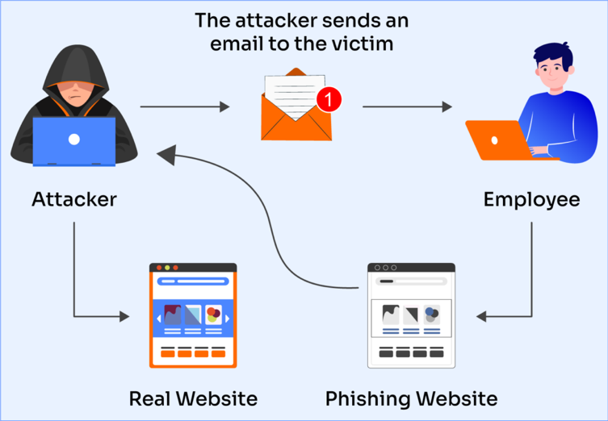
Figure 1:Example of a Phishing Attack

Email Phishing
Email phishing is the most common type of phishing attack. In this method, attackers send fraudulent emails that appear to come from legitimate organizations. These emails may include official logos, professional formatting, and convincing language to gain the trust of the recipient. Often, the email will contain a link that directs the user to a fake website where they are asked to enter personal information.
For example, a user may receive an email claiming that their bank account has been compromised and that they must log in immediately to secure it. If the user clicks the link and enters their credentials, the information is captured by the attacker (Cisco, 2023).

Website Phishing
Website phishing involves the creation of fake websites that closely resemble legitimate ones. These websites are designed to trick users into entering sensitive information such as usernames and passwords. Attackers may use domain names that look like real websites, making it difficult for users to notice the difference.
Once the user enters their information, it is immediately stored by the attacker and can be used for unauthorized access to accounts. This type of phishing is particularly dangerous because it can bypass basic user awareness if the fake website looks convincing enough (Commission, 2023).

Malware
Malware, short for malicious software, refers to any program or file that is designed to harm a computer system, steal data, or gain unauthorized access. Malware can be distributed through infected email attachments, malicious downloads, or compromised websites. Once installed, it can operate without the user’s knowledge and cause significant damage (Microsoft, 2023).
Different types of malwares serve different purposes, ranging from data theft to system disruption. As cybercriminals continue to develop more advanced malware, it becomes increasingly important for users to understand how these threats operate.

Viruses
Viruses are a type of malware that attach themselves to legitimate files or programs. When the infected file is opened, the virus activates and spreads to other parts of the system. Viruses can corrupt files, slow down system performance, and even render a device unusable.

Trojans
Trojans are malicious programs that disguise themselves as legitimate software. Users may unknowingly install a Trojan by downloading what appears to be a useful application. Once installed, the Trojan creates a backdoor that allows attackers to access the system and control it remotely (Microsoft, 2023).

Password attacks
Password attacks are methods used by cybercriminals to gain unauthorized access to user accounts by obtaining or guessing passwords. These attacks are particularly effective when users rely on weak or commonly used passwords. As many individuals reuse the same password across multiple platforms, a single compromised password can lead to multiple account breaches (Commission, 2023).

Brute Force Attacks
In a brute force attack, attackers systematically try all possible combinations of characters until they find the correct password. While this method can be time-consuming, it is effective against short or simple passwords.

Dictionary Attacks
Dictionary attacks involve using a list of common words and phrases to guess passwords. Since many users choose simple and predictable passwords, this method can quickly lead to successful account access.

Ransomware
Ransomware is a particularly harmful type of malware that prevents users from accessing their own data by encrypting it. Once the data is locked, attackers demand a ransom payment in exchange for restoring access. This type of attack can have serious consequences for both individuals and organizations, especially if important data is lost (IBM, 2023).

File Encryption
During a ransomware attack, files are encrypted using complex algorithms, making them inaccessible without a decryption key.

Payment Demands
Attackers typically demand payment in cryptocurrency to avoid detection. Even if the ransom is paid, there is no guarantee that access will be restored

Threat | Description | Impact
Phishing | Fake emails/websites | Data theft
Malware | Malicious software | System damage
Password Attacks | Guessing passwords | Account access
Ransomware | Locks files | Financial loss
Table 1:Summary of Common Cyber Threats

How to Stay Safe Online?

Use Strong Passwords
Using strong passwords is one of the most important steps in protecting online accounts. A strong password should be difficult to guess and include a combination of uppercase and lowercase letters, numbers, and special characters. Weak passwords such as “123456” or “password” are easily cracked by attackers using automated tools (Cisco, 2023).
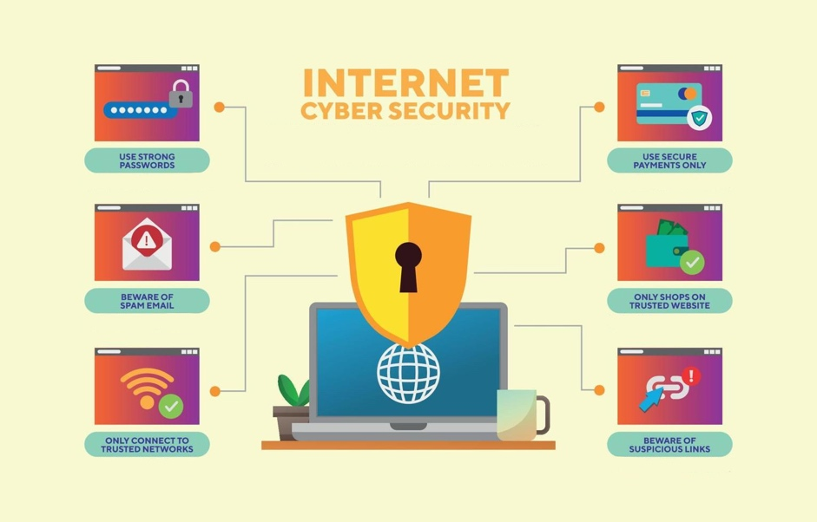
Additionally, users should avoid reusing the same password across multiple accounts. If one account is compromised, attackers may gain access to other accounts that use the same credentials. Therefore, creating unique passwords for each account significantly improves security.

Figure 2: Cyber Security Protection Methods

Password Complexity
Password complexity refers to the use of a mix of different characters to make passwords harder to guess. The more complex a password is, the more difficult it becomes for attackers to break it using brute force or dictionary attacks.

Password Managers
Password managers are tools that securely store and generate strong passwords. They allow users to maintain unique passwords for multiple accounts without having to remember each one. This reduces the risk of password reuse and enhances overall security (Microsoft, 2023).

Avoid Suspicious Links
Avoiding suspicious links is another essential cybersecurity practice. Cybercriminals often use links in emails, messages, or websites to redirect users to malicious pages designed to steal information. These links may appear legitimate but can lead to phishing attacks or malware infections (Commission, 2023).
Users should always verify the source of a link before clicking on it and avoid interacting with unknown or unexpected messages. Being cautious when browsing the internet can prevent many common cyber-attacks.

Email Links
Email links are commonly used in phishing attacks. Attackers send emails that encourage users to click on a link, often by creating a sense of urgency or fear. Once clicked, the link may lead to a fake login page where user credentials are stolen.

Fake Websites
Fake websites are designed to look like legitimate ones to trick users into entering personal information. Users should always check the website URL and ensure it is correct before entering sensitive data.

Use Antivirus Software
Antivirus software is an important tool that helps detect, prevent, and remove malware from computer systems. It acts as a protective layer against various cyber threats and ensures that systems remain secure (Microsoft, 2023).
Regularly updating antivirus software is essential, as it allows the system to recognize and respond to newly discovered threats. Without proper antivirus protection, devices are more vulnerable to attacks.

Real-Time Protection
Real-time protection continuously monitors system activity and detects potential threats as they occur. This allows users to respond immediately to suspicious behavior and prevent damage.

Malware Scanning
Malware scanning involves checking files and programs for harmful content. Regular scans help identify and remove threats before they can cause significant damage.

Keep Software Updated
Keeping software updated is a critical cybersecurity practice. Software updates often include fixes for security vulnerabilities that could be exploited by attackers. Failing to update software leaves systems exposed to known risks (IBM, 2023).
Users should enable automatic updates whenever possible to ensure that their systems remain protected against the latest threats.

Security Patches
Security patches are updates specifically designed to fix vulnerabilities in software. Applying these patches helps prevent attackers from exploiting known weaknesses.

Bug Fixes
Bug fixes address errors in software that could affect performance or security. Regular updates ensure that systems operate efficiently and securely.

Practice | Description | Benefit
Strong Passwords | Complex passwords | Harder to hack
Avoid Links | Don’t click unknown links | Prevent phishing
Antivirus | Detects malware | System protection
Updates | Install updates | Fix vulnerabilities

Table 2: Cyber Security Best Practices

Case Studies and Real-Life Examples

Email Scams
Email scams are among the most common forms of cyber-attacks and often rely on phishing techniques. In a typical scenario, a user receives an email that appears to come from a trusted organization, such as a bank or online service provider. The email may claim that there is an issue with the user’s account and request immediate action, such as verifying personal information or resetting a password.
If the user follows the instructions and provides their information, it is captured by the attacker and used for fraudulent purposes. These scams are effective because they exploit trust and urgency, making users act without carefully verifying the source (Commission, 2023).

Fake Bank Emails
Fake bank emails are designed to closely resemble official communications from financial institutions. They often include logos, branding, and professional language to appear legitimate. These emails typically contain links that lead to fake websites where users are asked to enter their login credentials.

Social Media Hacks
Social media platforms are frequent targets for cyber-attacks due to the large amount of personal information they contain. Hackers often gain access to accounts through weak passwords or phishing attacks. Once inside, they may send malicious messages to the victim’s contacts or use the account to spread scams (Microsoft, 2023).
In some cases, attackers may lock the original user out of their account and demand payment to restore access. This demonstrates the importance of securing social media accounts with strong passwords and additional security measures.

Account Takeover Methods
Account takeover methods include phishing, password guessing, and credential stuffing. These techniques allow attackers to gain control of user accounts and misuse them for malicious purposes.

Conclusion

In conclusion, cybersecurity is an essential aspect of modern life as individuals and organizations increasingly rely on digital technologies. This report has examined the concept of cybersecurity, the various types of cyber threats, and the strategies that can be used to prevent them. It is evident that threats such as phishing, malware, password attacks, and ransomware continue to evolve and pose significant risks to users worldwide.
The analysis has shown that many cyber-attacks exploit human behavior rather than technical weaknesses, making awareness and education critical components of cybersecurity. By understanding how these attacks work, users can make more informed decisions and avoid common mistakes that lead to security breaches.
Furthermore, implementing basic cybersecurity practices such as using strong passwords, avoiding suspicious links, installing antivirus software, and keeping systems updated can greatly reduce the likelihood of becoming a victim. These measures, although simple, are highly effective when applied consistently.
Ultimately, cybersecurity is a shared responsibility that requires continuous effort and attention. As technology continues to advance, users must remain vigilant and proactive in protecting their digital information. By adopting good cybersecurity habits, individuals and organizations can contribute to a safer and more secure digital environment (IBM, 2023).

References
(n.d.).
Centre, N. C. (2023). Cyber Security Guidance. Retrieved from NCSC: https://www.ncsc.gov.uk/guidance
Cisco. ( 2023). What is Cybersecurity? Retrieved from Cisco: https://www.cisco.com/c/en/us/products/security/what-is-cybersecurity.html
Commission, F. T. ( 2023). How to Recognize and Avoid Phishing Scams. Retrieved from FTC: https://consumer.ftc.gov/articles/how-recognize-and-avoid-phishing-scams
IBM. (2023). What is Cybersecurity? Retrieved from IBM: https://www.ibm.com/topics/cybersecurity
Microsoft. ( 2023). What is Malware? Retrieved from Microsoft: https://www.microsoft.com/en-us/security/business/security-101/what-is-malware

